

MobiVue PMMS

Ajanta Pharma Ltd.

Functional Specification Document (System Architecture & WMS_Admin)

This document includes the functional and non- functional requirements for specification of the application designed for Ajanta Pharma.

BAR CODE INDIA, 145 Udyog Vihar Phase 1, Gurugram, Haryana-122016, PH: 0124 4337555 1

Prepared By: Leena

Version Number: 1.0

BAR CODE INDIA, 691 UDYOG VIHAR PHASE V, GURUGRAM, HARYANA - 122016, Ph.: 0124 4337555

# Notice

This document contains information, which is the proprietary property of Bar Code India. This document is received in confidence and its contents cannot be disclosed or copied without the prior written consent of Bar Code India.

Nothing in this document constitutes a guaranty, warranty, or license, express or implied. Bar Code India disclaims all liability for all such guaranties, warranties, and licenses, including but not limited to: Fitness for a particular purpose; merchantability; not infringement of intellectual property or other rights of any third party or of Bar Code India; indemnity; and all others. The reader is advised that third parties can have intellectual property rights that can be relevant to this document and the technologies discussed herein and are advised to seek the advice of competent legal counsel, without obligation of Bar Code India.

Bar Code India retains the right to make changes to this document at any time, without notice. Bar Code India makes no warranty for the use of this document and assumes no responsibility for any errors that can appear in the document nor does it make a commitment to update the information contained herein.

COPYRIGHT

Copyright © ***BCI*** 2023. All rights reserved.

TRADEMARKS

*Other product and corporate names may be trademarks of other companies and are used only for explanation and to the owners' benefit, without intent to infringe.

# Revision History

|  |  |  |  |  |
| --- | --- | --- | --- | --- |
| Revision Number | Date | Prepared By | Reviewed By | Comment |
| 00 | 22.05.2023 | Leena Patil | Sailendra Das | Functional & Design Specification document |

Table of Contents

Notice 2

Revision History 3

1 Protocol Approval 6

2 Introduction 7

3 OBJECTIVE 7

4 SCOPE 7

5 Functional Requirements 8

5.1 System Architecture 8

5.2 Object Model Workflow 9

5.2.1 Mobivue PMMS Code Data Flow 9

5.2.3 Communication Flow (SAP -BCI) 10

5.2.4 API Access Token 11

5.3 Hardware and Software Details 12

5.3.1 Hardware Details 12

5.3.2 Software Details 13

5.4 Interfaces 14

5.4.1 Architecture 14

5.4.2 Component Descriptions 15

5.5 WMS Application Flow 16

5.6 Flow Diagram for the Inward Process 17

5.7 Flow Diagram for Sampling Process 18

5.8 Flow Diagram for Dispensing process 19

5.9 Electronic Log System:- 20

5.9.1 Error Logs 20

5.9.2 Audit Logs 20

5.10 Error, and Warning Messages 20

5.11 Security 22

5.11.1 Authentication 22

5.11.2 Authorization 23

5.11.3 Auditing 23

5.12 Plant Registration Details 23

6 Application Modules 24

6.1 User Management 24

6.1.1 User Management 25

6.1.2 Role Management 26

6.1.3 Password Management 27

# 

# Protocol Approval

|  |  |  |  |  |
| --- | --- | --- | --- | --- |
| **M/S Bar Code India Ltd.** | | | | |
|  | **Name** | **Department** | **Designation** | **Sign & Date** |
| Prepared By |  | Software | Technical Document Writer |  |
| Reviewed By |  | Software | Business Analyst |  |
| Reviewed By |  | Software | Development Lead |  |
| Reviewed By |  | Software | Quality Tester |  |
| Approved By |  | Software | Software Quality Lead |  |

|  |  |  |  |  |
| --- | --- | --- | --- | --- |
| **Ajanta Pharma Ltd :-** | | | | |
|  | **Name** | **Department** | **Designation** | **Sign & Date** |
| Reviewed By |  |  |  |  |
| Reviewed By |  |  |  |  |
| Reviewed By |  |  |  |  |
| Reviewed By |  |  |  |  |
| Reviewed By |  |  |  |  |
| Approved By |  |  |  |  |

# Introduction

The purpose of this document is to list down all the system function solutions for the business need identified by the user.

# OBJECTIVE

The Functional Design Specification Document is a document that provides detailed information on how the system solution will function and the requested behavior. The document is created based on the requirements identified by the user.

# SCOPE

This document will contain the functional details of the Mobivue PMMS system (System Architecture and Module-Admin)

# Functional Requirements

**

The architecture has the following components:

* **Web:** Web Frontend which is created using Angular 12 (A front end development language) and App services which are created using .Net core framework. App Service is a fully managed web hosting service for building web applications, services, and Restful APIs.
* **Database:** SQL database to keep data.
* We would be using three servers for production, Quality and development server (Staging) respectively.
* **SAP is connected to Plant side and not Central server for data transfer. – All data will be updated directly in the SAP from BCI system, data transfer as per the process to server.**

## Object Model Workflow

### Mobivue PMMS Code Data Flow

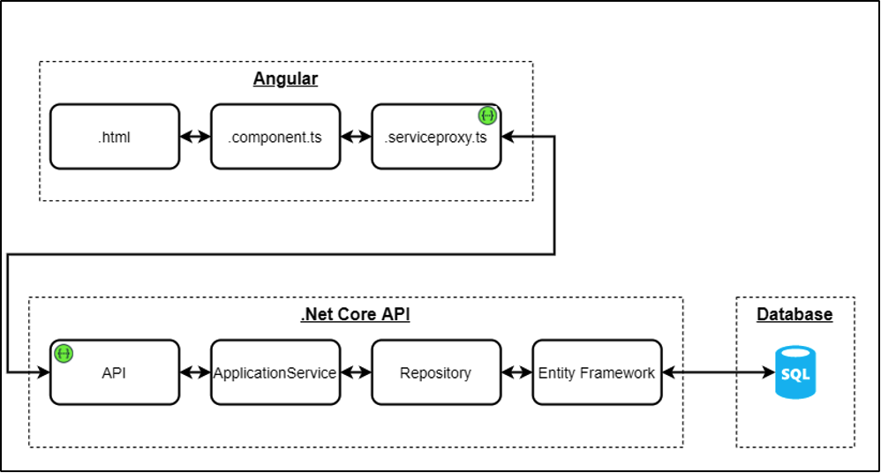

The above diagram shows the data flow that happens in code. Since our code is based on Angular and .Net core based API’s the diagram depicts the file types used in code architecture. Our Database is MSSQL and API’s can connect to MSSQL for data modification or fetching.

### Communication Flow (SAP -BCI)

We have created a middleware connector in our code which communicates with SAP and Mobivue PMMS to keep the data in sync.

### API Access Token

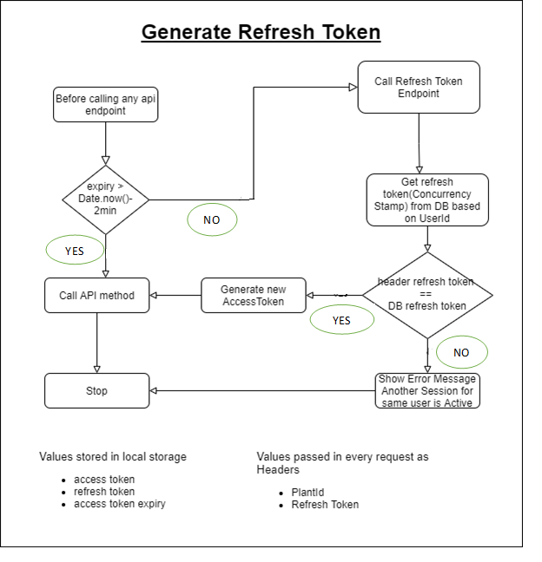

To ensure better security while calling API’s we use access Tokens which are generated or refreshed based on a time interval. If the access token is expired the API call will fail and system will be required to access Refresh token API. The API’s are under the access token control means to use this API’s password required which avoid any miss use of the API.

## Hardware and Software Details

### Hardware Details

1. Zebra Desktop printer ZD23042-30GC00EZ
2. Zebra Industrial printer ZT41142- T0G0000Z
3. Zebra Industrial Tablet ET51CTG21 (Android Version 8.1, Storage 32 GB)
4. Zebra Mobile Computer MC930BG (Android Version 8.1, Storage 32 GB)

**MobiVue PMMS Client:-**

* Since MobiVue PMMS client is a browser, it can run on any latest browser on any operating system. System requirement for Mobivue PMMS is same as Angular 12 system requirements except that MobiVue PMMS will need additional RAM and computing power.

**Following Servers will be required:**

1. Application Server for UAT/Quality Environment
2. Database Server for UAT/Quality Environment
3. Application Server for Production Environment
4. Database Server for Production Environment

**Below hardware configurations will be required for Server (UAT/Quality Environment):**

Processor: 32-bit or 64-bit

Minimum RAM: 8 GB or higher

Hard Disk: Minimum 50GB

**Following browser will be applicable for quality server:**

Quality server will have two sub servers:

i. Development server http://172.16.200.28:4200/Dev

ii. UAT/Quality server <http://172.16.200.28:4300/Qty>

**Following Database server will have 2 databases for quality server**

1. Development Data base server –DEV_AjantaDBGHT
2. UAT/Quality Database server --- QTY_AjantaDBGHT

**Below hardware configurations will be required for Server (Production Environment)**

Processor: 32-bit or 64-bit

Minimum RAM: 32 GB or higher

Hard Disk: 1TB or higher

### Software Details

Mobivue PMMS system is a thoughtfully developed, well-structured and web based application. It is specially designed for the material management, GRN posting, sampling and dispensing in pharmaceutical industries complying with different international quality standards. To achieve smooth workflow process DMS follows role-based work flow functionalities.

**Software Configuration Details**:

We configure the application by using Internet Information services (IIS) for here we are using the below version.

IIS version: 10.0

**Following application will be required in Server for both environment (Quality & Production):**

Server OS: Window server 16 or higher

Database application: MSSQL

## Interfaces

### Architecture

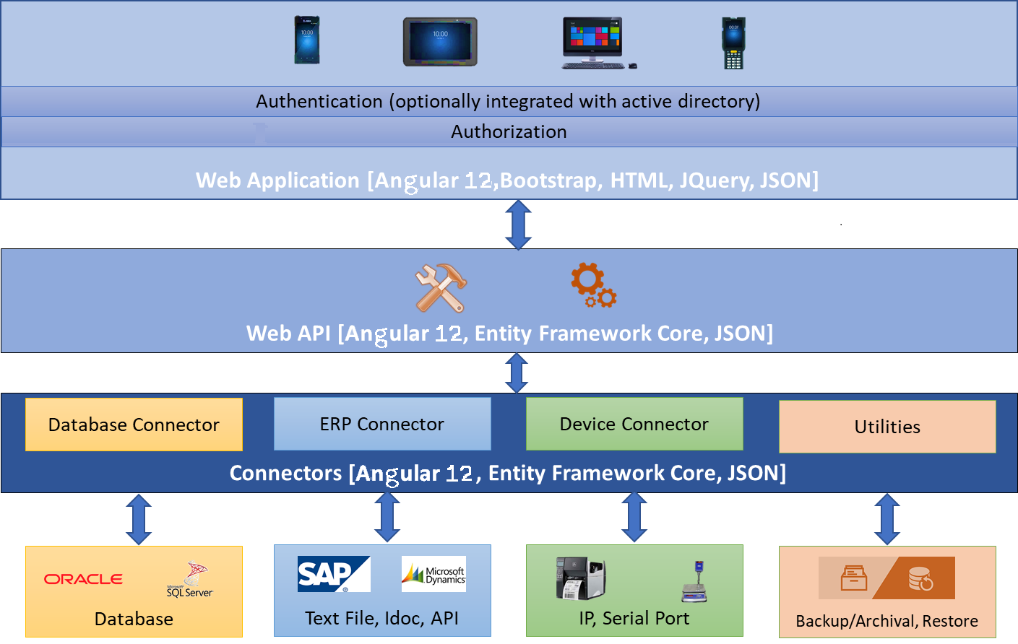This system is a web-based solution. This is developed on Model-View-Controller (MVC) architecture using Angular 12. All the components are integrated in a loosely coupled way to make the system robust, scalable and expandable. Especially, the connector layer that consists of database providers, 3rd party interfaces and device connectors are written in such a way that any of the connectors can be plugged in and out or changed. E.g. any RDBMS (Relational Database Management System) can be used as database, any ERP like SAP, MS Dynamics, etc. can be integrated, scanners of any make and model can be used for scanning etc. Following image shows the architecture of Mobivue PMMS representing all components of the system.

### Component Descriptions

#### UI or Client Layer

UI is a browser-based interface managed and controlled by ASP.Net 3.1, HTML 5, CSS, Bootstrap, JQuery and JSON. All latest browsers will be supported for this system on any operating system and any devices – be it a PC, Laptop, Tab or smart phone. To perform any operation or action on the system, users will need to be authenticated first.

This system has its own authentication component which is forms-based authentication. User will provide username and password to login. Additionally, this system authentication system can be integrated to customer’s own authentication system for extra level of security.

Once the user is authenticated, system will present the UI based on the access for the currently logged in user. Access for the user will be defined by the administrator.

#### Web API or Server Layer

This system Web API will be the heart of the system. All business logic and data manipulations will be done in this layer. Web API will be secured through API Key security and this will not be known to the customer for whom the system is hosted. API Key will be a secret for except the designated ones.

#### Connectors Layer

This will be most dynamic and loosely coupled component of this system, to provide the flexibility of choice of databases, ERPs and devices.

## WMS Application Flow

MobiVue Pharmaceutical Manufacturing Management System is developed and implemented for Ajanta Pharma Limited to automate system at Warehouse the solution will facilitate user to manage the storage of inventory at warehouse and also helps in efficient allocation of Material for Sampling and Dispensing. Barcode Labels will be generated for all the received Material pack i.e. Containers or Bags against the Gate Entry Number. The materials will be tracked through this barcode in process i.e. picking, pre-staging, staging, dispensing, put-away during movement the materials will be validated against the system input data process order , Inspection lot no. The application also provides identification for Equipment, Dispensing Booths, Weighing Balance, In-process machines, Pallets, and process/dispensing rooms. This application has been using the English (US) language for interface.

## Flow Diagram for the Inward Process

*For the Digram Refer attached Annexure- I*

**Inward Module:** - Basic function of the inward module is, from material gate entry to storage in ware house and posting details in the BCI and same data reflect in SAP vice versa as per the process requirement .It consists of different sub modules as below

* **Gate entry:** - This sub module use to entry the materials in side factory premises after initial verification and data entry.
* **Vehicle inspection: -** This sub module use for verification of the vehicle in which the material transported as per the defined checklist.
* **Material inspection: -** In this Sub module material verification carried out as per the defined checklist and enter the material data as per requirement.
* **Weight/Quantity Verification: -** In this Sub module weight /quantity verification of the materials carried out as per the user requirement.
* **GRN posting/GRN Cancel/GRN re-posting:-** These Sub modules use to post all the required data/information in to the SAP system and BCI system receive respond details from the SAP as per the process requirement.
* **Label printing: -** In this Sub module Bar code labels are printed for each container/pack as per the received material.
* **Palletization/Put away/Bin to Bin transfer: -** These Sub modules are used for handling & storage of the materials inside the ware house.

## Flow Diagram for Sampling Process

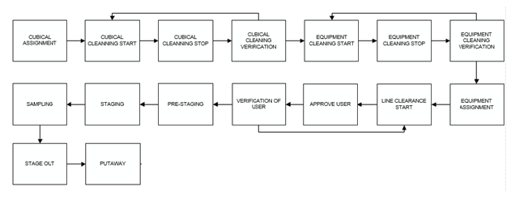

**Sampling Module: -** Basic function of this module is to perform sampling of the materials as per the procedure. This module consist of below sub-modules

* **Cubicle assignment: -** This sub-module use for assignment/de-assignment of the cubicle to the materials for the sampling activity as per the planning**.**
* **Cubicle cleaning: -** Perform cleaning and cleaning verification of the cubicle as per the process and capture real time of the activity**.**
* **Equipment Cleaning: -** Basic function of this sub-module is to perform cleaning and cleaning verification of the equipment’s.
* **Equipment assignment: -** In this sub-module equipment assignment and de-assignment carried out for the sampling activity as per the planning.
* **Line clearance: -** This sub-module is use to perform line clearance of the cubicle i.e. checking and verification of the cubicle area as per the defined checklist based on the observation further process decided.
* **Picking/Pre-Staging/Staging: -** These sub-modules are used for the movement of the material from the material storage location to the sampling cubicle.
* **Sampling: -** This sub-module use for the sampling of the materials based on the unit of measurement the sampling can be done by performing weighing or counting the sample quantity.
* **Stage out: -** This sub-module use for handling the containers after completion of the sampling activity.
* **Put-away: -** This sub-module use for handling of the remaining materials and its storage.

## Flow Diagram for Dispensing process

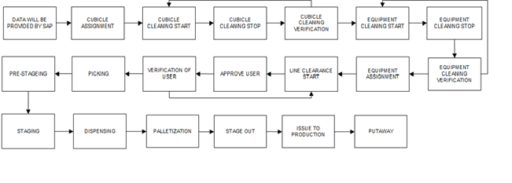

**Dispensing Module: -** Basic function of this module is to dispense the materials as per the process order from production based on the unit of measurement and post the data details in Software and data transfer to SAP. This module consist of below sub-modules.

* **Cubicle assignment: -** This sub-module use for assignment/de-assignment of the cubicle for the process order planning for dispensing activity.
* **Cubicle cleaning: -** Perform cleaning and cleaning verification of the cubicle as per the process and capture real time of the activity**.**
* **Equipment Cleaning: -** Basic function of this sub-module is to perform cleaning and cleaning verification of the equipment’s.
* **Equipment assignment: -** In this sub-module equipment assignment and de-assignment carried out for the dispensing activity as per the planning.
* **Line clearance: -** This sub-module is use to perform line clearance of the cubicle i.e. checking and verification of the cubicle area as per the defined checklist based on the observation further process decided.
* **Picking/Pre-Stage /Staging: -** These sub-modules are used for the movement of the material from the material storage location to the dispensing cubicle.
* **Dispensing: -** This sub-module use for the dispensing of the materials based on the unit of measurement, dispensing can be done by performing weighing or counting the quantity.
* **Palletization –** This sub-module is use for Palletization of the dispensed materials.
* **Stage out: -** This sub-module use for handling the containers after completion of the dispensing activity.
* **Issue to production: -** In this sub-modules basic function is to post the dispensed material in the BCI and issue note no receive from SAP to BCI.
* **Put-away: -** This module use for handling of the stage out material for storage.

## Electronic Log System:-

System shall maintain different internal logs for application.

### Error Logs

These logs will contain any errors encountered during runtime for faster resolution of any problem post deployment. These logs are captured by the system for verification and troubleshooting of any abnormal observation or malfunctioning during process activity. This will be under access of the developer level.

### Audit Logs

These logs will monitor the activities of user who accessed the application, made changes to File/ Document and the time stamp of these activities.

## Error, and Warning Messages

Application users will get error/ alarm/ warning messages in following conditions:

**Error Message will appear:-**

* In case, user entered incorrect Login credentials.
* If user has clicked on Forgot Password button without entering Employee Code.
* In case user has entered invalid/in-active user id/Email on Forgot Password & Reset Password screen.
* In case user has entered different Password in New Password and Confirm Password text fields.
* In case, user has entered one of the 3 previous Passwords during resetting Password.
* In case, length of the Password entered does not satisfy the max-min validation.
* In case, user tries to save details without entering a mandatory field.
* In case, user has entered invalid data in a mandatory field and tries to save the details.
* In case, user tries to save already existing details.
* In case, user has entered invalid data i.e. Purchase Order, Process orders, Material codes Number during Process
* In case, user has scanned an invalid barcode or duplicate barcode

**Warning Message will appear**:-

* If user has left the Employee Code text field blank on Forgot Password screen.
* If a mandatory field has not been filled.
* If user select any date prior to current date for Stamping Done On field in Weighing Balance Master module.
* If user select Stamping Due On date prior to Stamping Done On date in Weighing Balance Master module.
* If user enter Capacity or Standard Weight of weighing scale with digits after decimal more than least count.

## Security

The Mobivue PMMS system will be secured by implementing authentication and authorization features. The following image shows the difference between two (i.e. authentication and authorization).

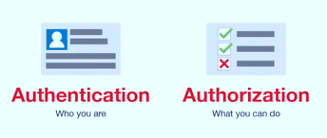

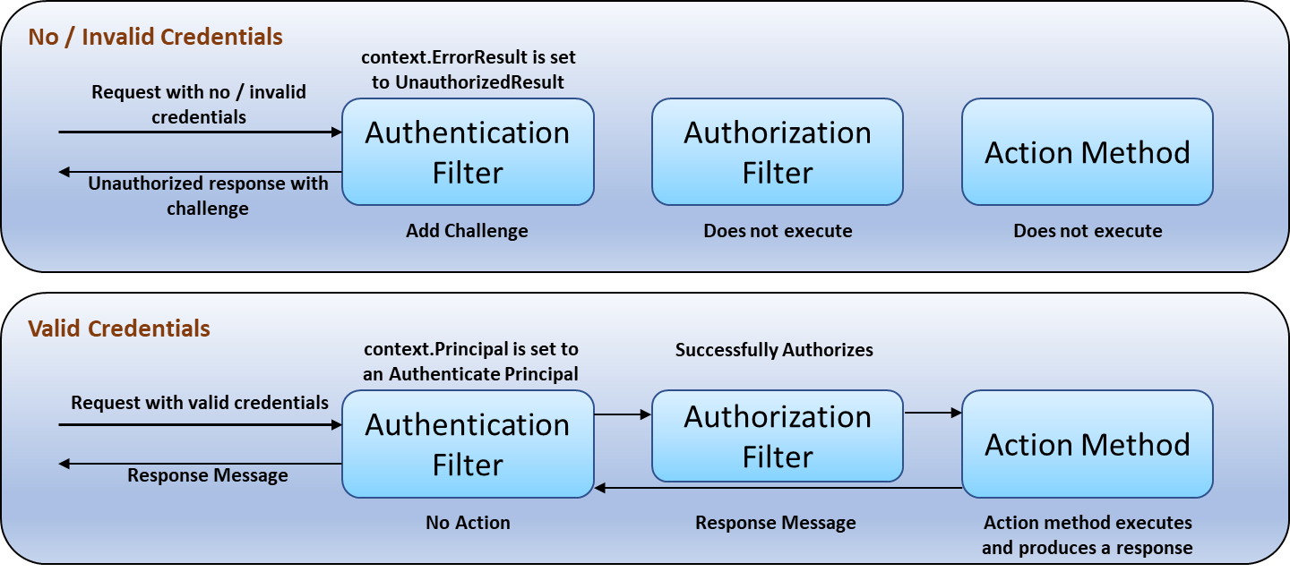System will provide form-based authentication mechanism where user must provide valid username and password to log into the system. Each user must have an entry in the database with his/her username and password. Activity of adding a new user to the system will be done by the administrator of the system.

### Authentication

Mobivue PMMS will have its own standard forms authentication module. Password will be stored in the database as an encrypted string, so that even someone with direct database access should not be able to see it.

Above image shows the flow for no or invalid credentials and valid credentials.

### Authorization

The features / modules available in Mobivue PMMS will be input as seed. Administrator will only assign the access for these features / modules to individual roles of the users.

Above image shows the flow for no or invalid credentials and valid credentials.

### Auditing

Every time a user logs in to or logs out of Mobivue PMMS, a corresponding entry will be done in the Audit Log table. Session outs are also tracked and audited.

The format generated in audit trial will be non-editable format.

## Plant Registration Details

Database Name on Ajanta Server will be as follows:

**Production Database Name** – Ajanta DB  
**QA Database Name** – Ajanta DB_QA  
**Development Database Name** – Ajanta DB_Dev

Option will be provided to the authorized user for modifying the registered plant by providing details such as remark(s)/ Reason

* Plant code and DB Name will be in non-editable format

*Address will be in editable format

# Application Modules

## User Management

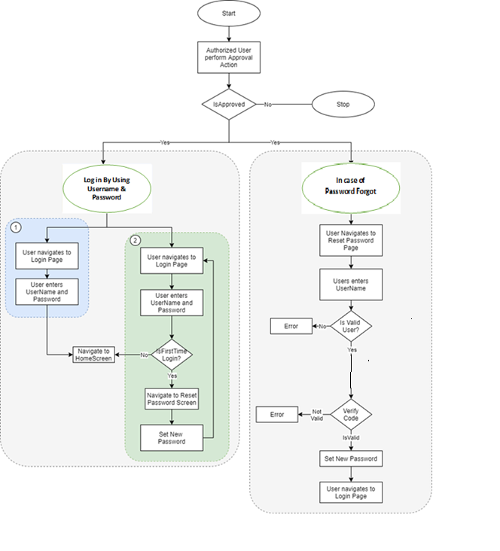

The module will let application administrator to manage the Users, and the rights assigned to the same; the rights will define authorized application access of users.

The User Management & Master data will be created using **Web Application.**

### User Management

This module will let user to create application users who will access the application. To keep the system secured and track activities done by different users, user need to be registered to the system. System provides following functionalities to manage users. User master will be integrated with Active directory of customer.

The master will store the users’ details in system.

**Note:** Super Admin is a special user which is seeded during system hosting and not created using the system user interface.

|  |  |
| --- | --- |
| **Data Fields** | 1. First Name 2. Last Name 3. Phone Number 4. Select Designation 5. Select Reporting Manager 6. Employee Code 7. Email 8. Remark 9. Password 10. Confirm Password 11. Is Active 12. Role |
| **Process Steps** | 1. Open the screen and click on add button, enter required details such as First Name, Last Name, and Phone Number. 2. Select Designation, Sub Plant, and Reporting Manager from dropdown. 3. Enter Employee Code, Email, Password, Confirm Password. 4. Select Status as Is Active if it is active. 5. Click on the add, in grid view its approval status will be displayed as submitted. 6. Second authorized person will Approved / Reject after giving appropriate remark then the approval status will be updated accordingly. 7. Save the details in database details will be display in grid. 8. Grid view details as user first name, user last name, employee code, creation date, PW reset date, approval status, status and action. 9. Based on the active /in active status will be display i.e. in case of the active it will show green color and in case of inactive it show red color. 10. By selecting the action details of the entry will be display. 11. Selecting the back/cancel button user can return to the main grid screen from the particular screen without any change. |
| **Functions** | Add, edit, approve/reject, search and filter the user as per the requirement. |
| **Role** | User Management |

### Role Management

This module will let user to create specific role as per the user requirement.

|  |  |
| --- | --- |
| **Data Fields** | 1. Role Name 2. Display Name 3. Description 4. Remark 5. Is Active 6. Permissions |
| **Process Steps** | 1. Open the screen and click on add button, enter the Role Name, Display Name, Remark and Description as per the requirement. 2. Select Status as Is Active if role is active. 3. Select the Permission by clicking against Module-Sub modules names in data grid. 4. Save and Update the details in database and details will be display in grid view. 5. Grid details as Role Name, Display Name, Description, Approval status, Status and Action. 6. Based on the active /in active status will be display. 7. By selecting the action details of the entry will be display. 8. Selecting the back/cancel button user can return to the main grid screen from the particular screen without any change. |
| **Functions** | Add and approve/reject Roles as per requirement |
| **Role** | Role management |

### Password Management

This module will let Admin reset the password of application users after receive of the requisition. Once the password gets reset by admin, then admin will share the password with the user and authorized users can access the application.

|  |  |
| --- | --- |
| **Data Fields** | 1. First Name 2. Last Name 3. Employee Code 4. Password 5. Confirm Password |
| **Process Steps** | In case of the user forgot password: -   1. In log in screen user will enter the employee code. 2. Then click on the forgot password button, after that enter the employee code in the display screen click on the submit button. 3. It will now display in the password management screen in admin log in for the password re-set.   In admin log in:-   1. First Name, Last Name, and Employee Code of the user whose password needs to reset will be displayed on the screen. 2. Enter the password and confirm the Password, add the details. 3. Admin can see the Status of User is changed pending to Submitted. 4. User will guide by the system to change the password during 1st time log in. 5. Admin can see the Status of User is changed Submitted to Completed. 6. Save and Update the details in database details will be display in the grid. 7. The grid display as employee code, first name, last name, request, status and action. 8. In request column will show the reason for the password re-set. 9. Clicking the back button user can return to the main screen. |
| **Functions** | Authorized user can reset password of users as per requirement after receive notification. |

1. The system will not allow creation of duplicate User Ids.
2. System & record access will be limited to authorize users only.
3. Guest account will not be available in system.
4. Provision will be available in system for auto log off after predefined time period (Preferable 05 min.).
5. Facility for password complexity will be available in system (special character, numeric and uppercase).
6. In system, provision will be available to accept minimum password length of 8 characters.
7. System will not allow last 03 used password.
8. Provision will be available in system for mask the password during enter.
9. Provision will be available in System to lock password after 90 days if not changed before expiry.
10. The system will be lock User IDs after consecutive invalid login attempts to the system (03 invalid attempts).
11. Provision to change password for the first time user login will be available in system.
12. Only authorized person will be able to re-set the password.
13. Role wise user privilege facilities will be available in system.
14. Provision will be available in system for Role-wise user privileges creation & it can be under control by authorized function.

**Remark: -**

* Modules and Sub-modules are mentioned in the system to display no. of modules and sub-modules available in the system. The module and sub-module do not have any functional activity in the process.
* Module screen contains module name, display name, description ,status and action column
* Sub-Module screen contains sub-module name, display name, Module name, a status and action column.